Right To Counsel Eviction Help Social Media Kit
For use in 2023 in Oklahoma City, Ok Zip Codes 73111, 73119, and 73120

Where possible, please tag Legal Aid Services of Oklahoma on the social network to which you are posting. Also be sure to include the Zip Codes targeted by this program.

Download High-Resolution Graphics Here:
https://www.dropbox.com/sh/c0edy99jgifq0ij/AABuS_K0yM5YNi7b-Y5-BGkDa?dl=0

Here's how to use these social media graphics and captions:
- Download the graphics with the link above
- Copy the caption you want to use from the table below
- Post the graphic on your social media channel and paste in the caption

Legal Aid Services of Oklahoma, Inc Social Media Accounts to Tag:
Instagram — @legalaidok Facebook — Legal Aid Services of Oklahoma, Inc
Twitter — @LegalAidSvcs_OK LinkedIn — Legal Aid Services of Oklahoma, Inc

Social Media Graphic and Size | Caption or Suggested Uses
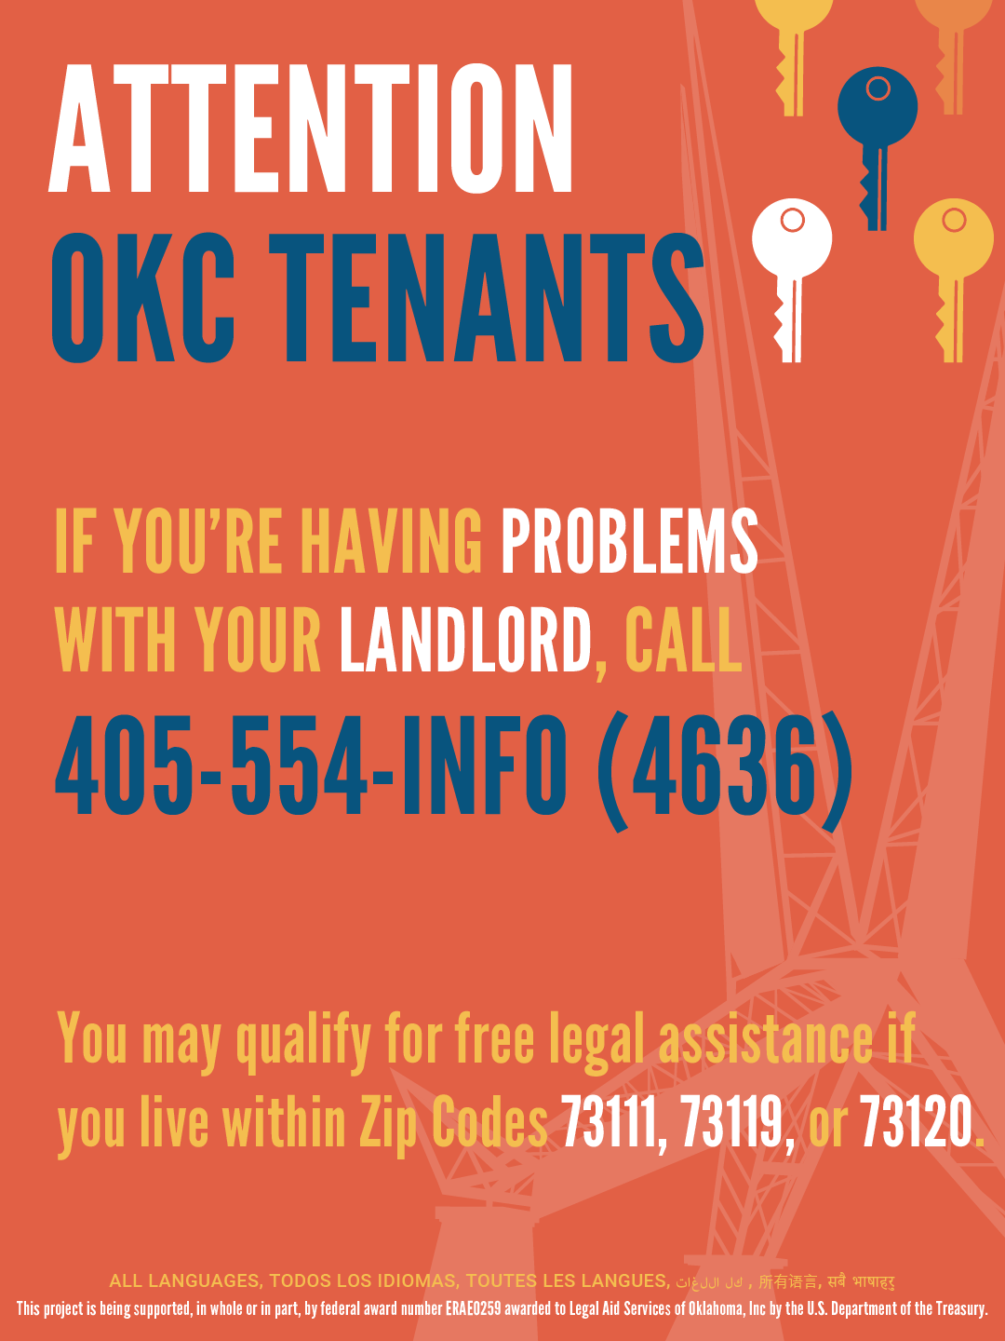  OKC Port 1 (English).png in Portrait Ratio | Tenants in OKC need to know about the assistance available to you from @legalaidok. You may qualify for free legal assistance and information if you live within Zip Codes 73111, 73119, or 73120.  Call 405-554-4636 as soon as you begin having problems.  Don't live in these Zip Codes? There's still help and information available for your landlord problems or eviction. Visit https://oklaw.org/issues/housing/evictions
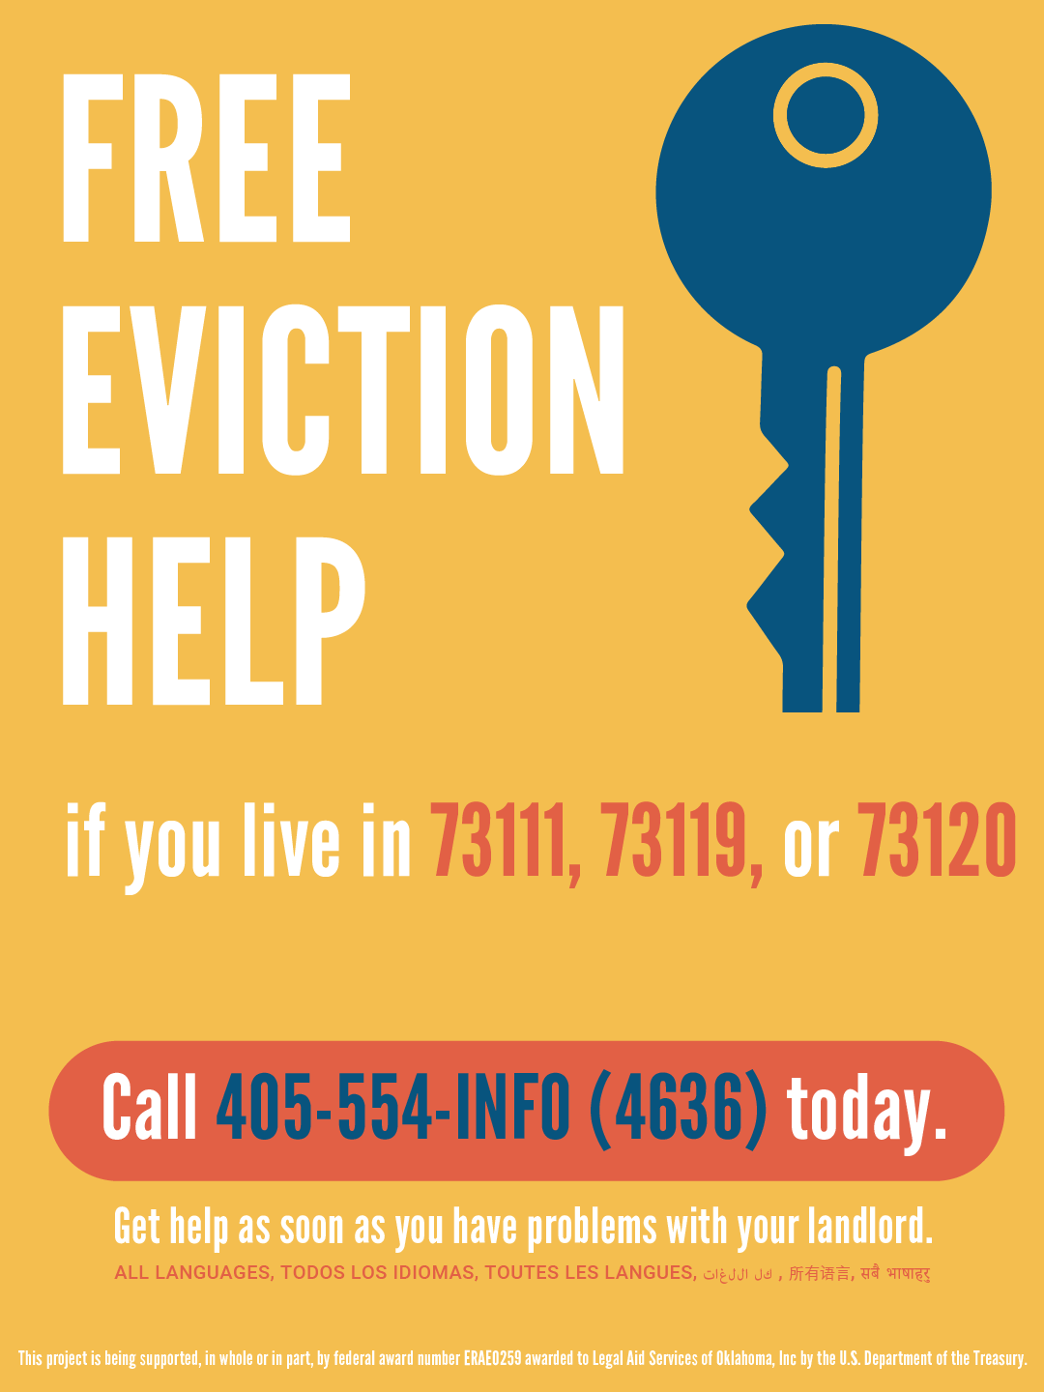  OKC Port 2 (English).png in Portrait Ratio | We think you should know about the free eviction help from @legalaidok for those who live in Zip Codes 73111, 73119, or 73120. Call 405-554-INFO (4636) as soon as you have problems with your landlord.  Don't live in these Zip Codes? There's still help and information available for your landlord problems or eviction. Visit https://oklaw.org/issues/housing/evictions
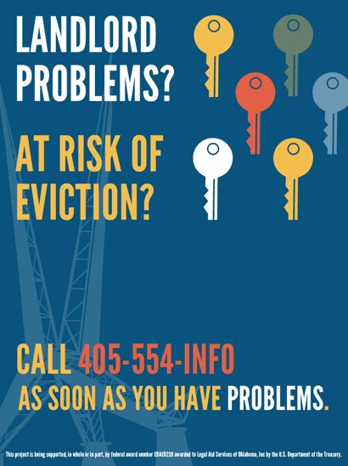  OKC Port 3 (English).png in Portrait Ratio | If you’re facing eviction or having problems with your landlord, you have a right to get legal advice or representation to help you. You may qualify for free help from @legalaidok if you live in Zip Codes 73111, 73119, or 73120.  Call 405-554-4636 as soon as you begin having problems.  Don't live in these Zip Codes? There's still help and information available for your landlord problems or eviction. Visit https://oklaw.org/issues/housing/evictions
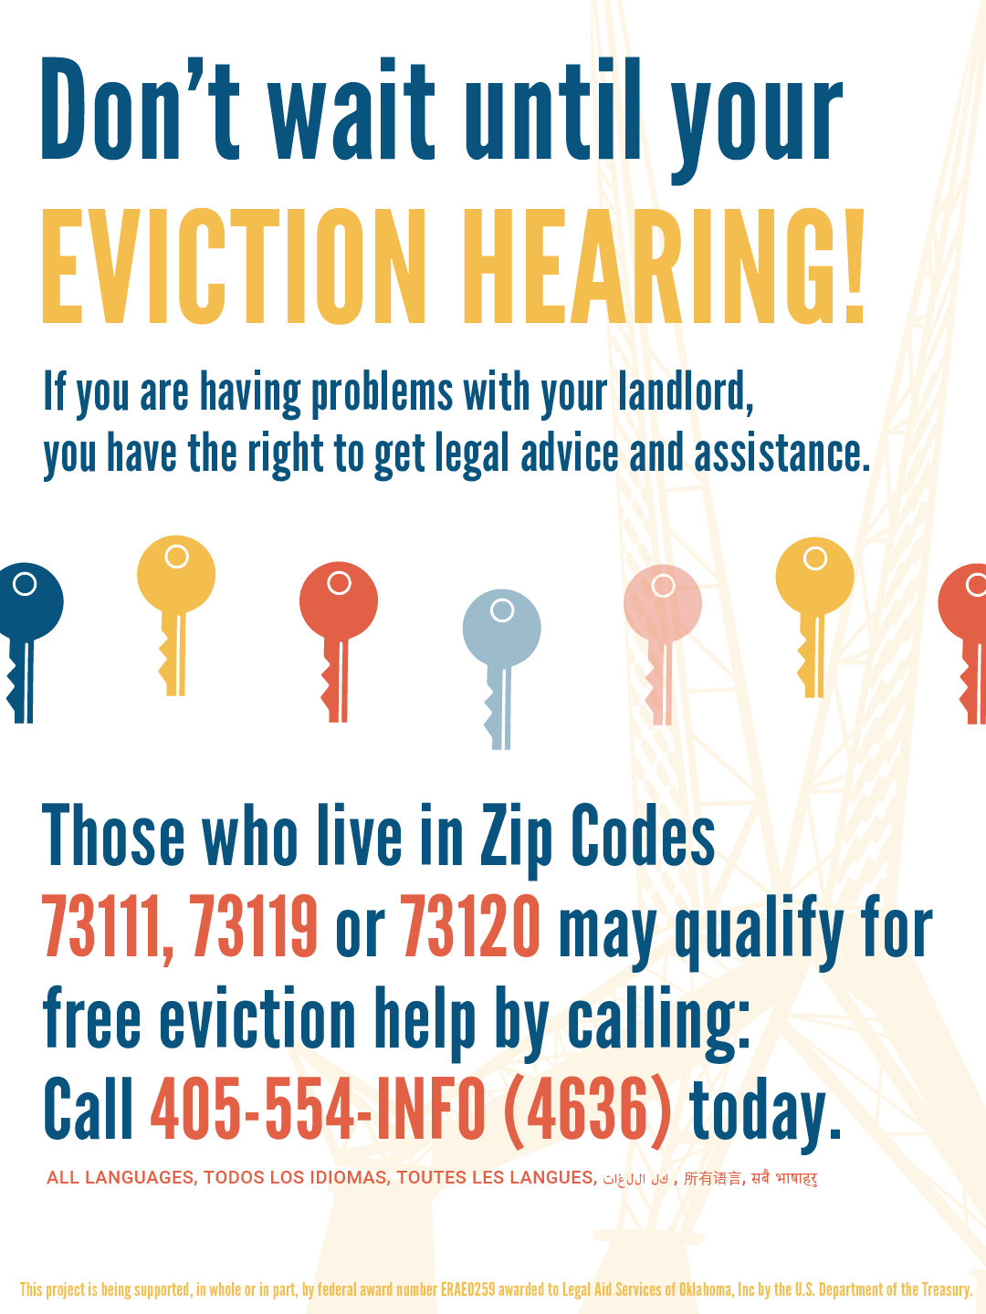  OKC Port 4 (English).png in Portrait Ratio | You can get help BEFORE your eviction hearing if you’ve been having problems with your landlord! @legalaidok reminds you of your “right to counsel.”  Get free legal advice and representation if you qualify and live in Zip Codes 73111, 73119, or 73120. Call 405-554-INFO (4636) today.  Don't live in these Zip Codes? There's still help and information available for your landlord problems or eviction. Visit https://oklaw.org/issues/housing/evictions
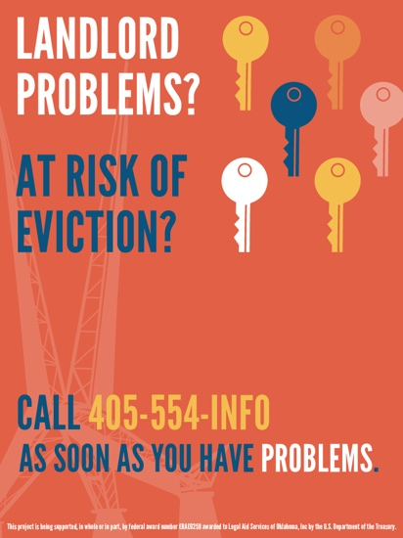  OKC Port 5 (English).png in Portrait Ratio | Live in Zip Codes 73111, 73119, or 73120 and having problems with your landlord? @legalaidok might be able to help!  Call 405-554-4636 to get advice and help BEFORE your eviction hearing.  Don't live in these Zip Codes? There's still help and information available for your landlord problems or eviction. Visit https://oklaw.org/issues/housing/evictions
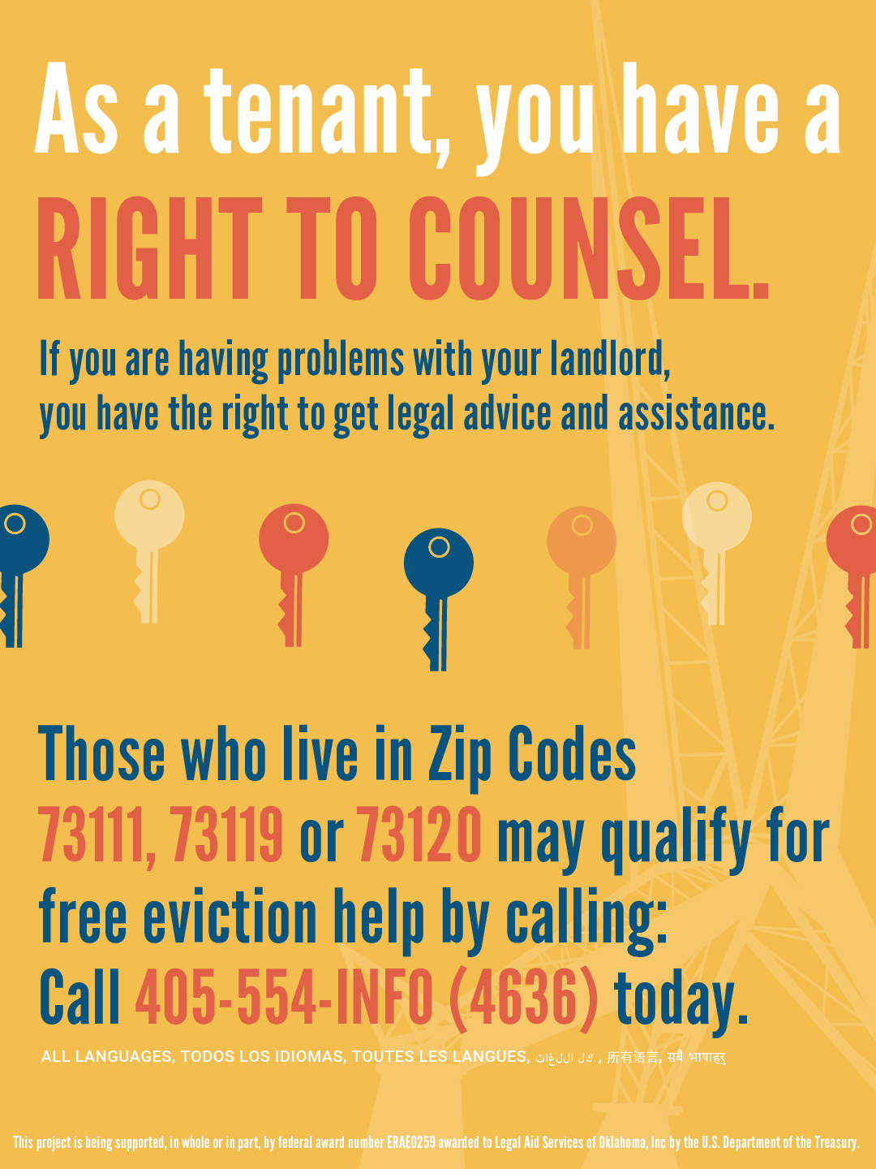  OKC Port 6 (English).png in Portrait Ratio | If you’re facing eviction or having problems with your landlord, you have a right to get legal advice or representation to help you. You may qualify for free help from @legalaidok if you live in Zip Codes 73111, 73119, or 73120.  Call 405-554-4636 as soon as you begin having problems.  Don't live in these Zip Codes? There's still help and information available for your landlord problems or eviction. Visit https://oklaw.org/issues/housing/evictions
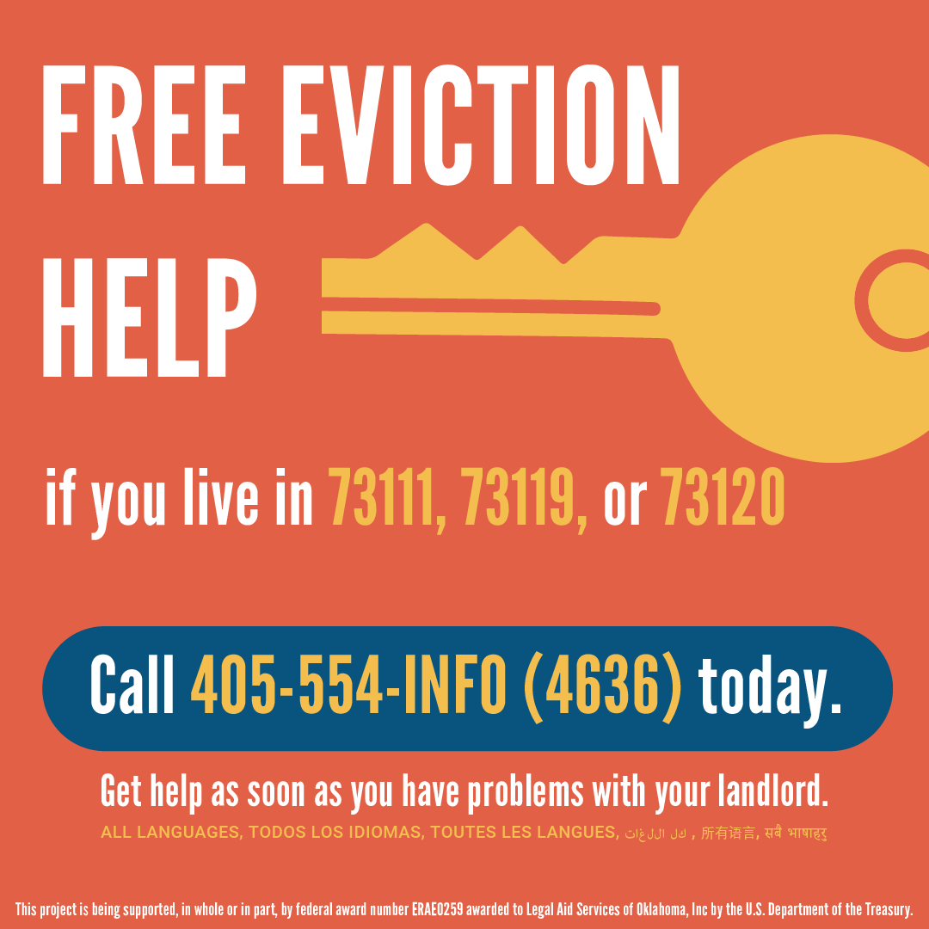  OKC Square 1 (English).png in Square Ratio | Problems with your landlord? @legalaidok might be able to help you. Call 405-554-INFO (4636) as soon as you begin having problems.  Don't live in these Zip Codes? There's still help and information available for your landlord problems or eviction. Visit https://oklaw.org/issues/housing/evictions
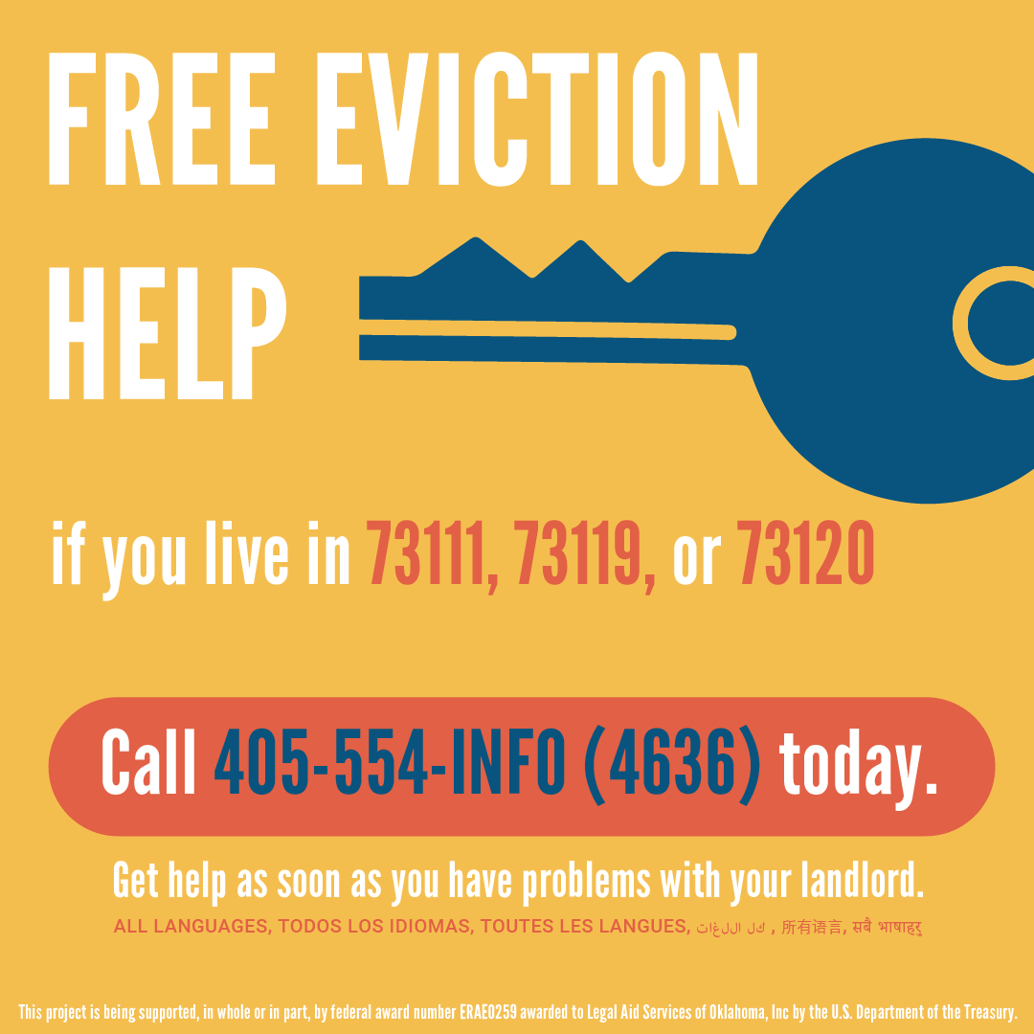  OKC Square 2 (English).png in Square Ratio | We think you should know about the free eviction help from @legalaidok for those who live in Zip Codes 73111, 73119, or 73120. Call 405-554-INFO (4636) as soon as you have problems with your landlord.  Don't live in these Zip Codes? There's still help and information available for your landlord problems or eviction. Visit https://oklaw.org/issues/housing/evictions
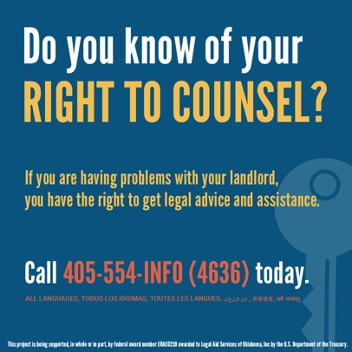  OKC Square 3 (English).png in Square Ratio | If you’re facing eviction or having problems with your landlord, you have a right to get legal advice or representation to help you. You may qualify for free help from @legalaidok if you live in Zip Codes 73111, 73119, or 73120.  Call 405-554-4636 as soon as you begin having problems.  Don't live in these Zip Codes? There's still help and information available for your landlord problems or eviction. Visit https://oklaw.org/issues/housing/evictions
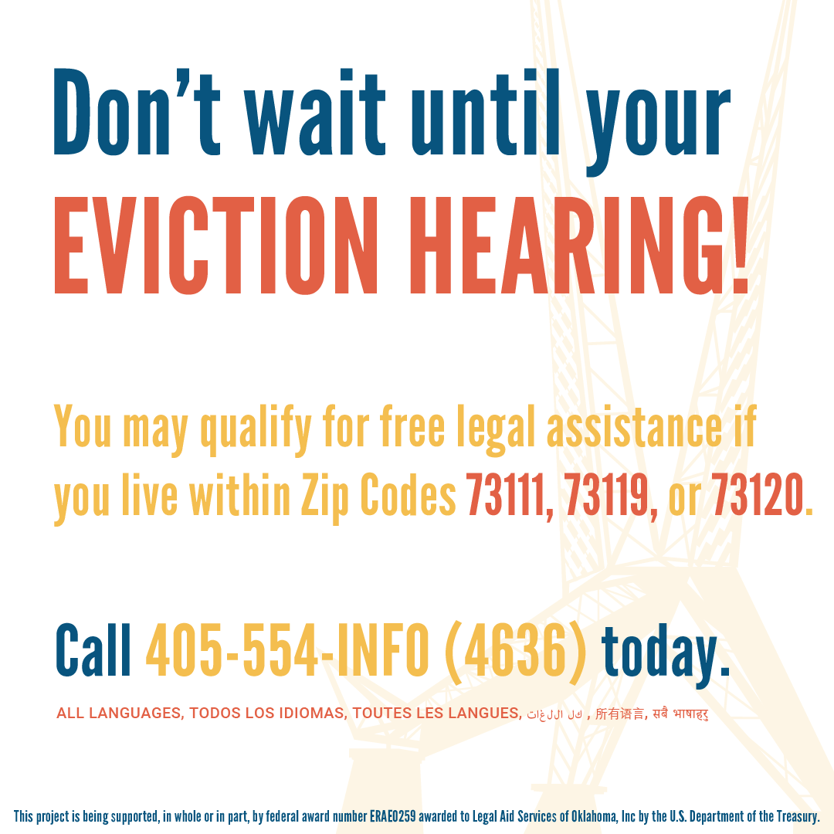  OKC Square 4 (English).png in Square Ratio | Do not wait until your eviction hearing to ask for help. @legalaidok might provide you with free advice and representation if you live in Zip Codes 73111, 73119, or 73120. Call 405-554-INFO today.  Don't live in these Zip Codes? There's still help and information available for your landlord problems or eviction. Visit https://oklaw.org/issues/housing/evictions
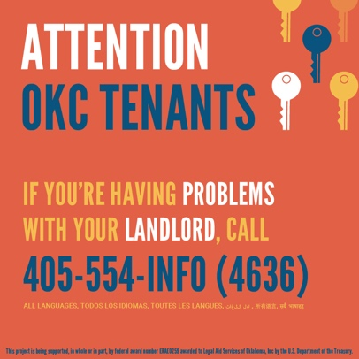  OKC Square 5 (English).png in Square Ratio | Help for OKC tenants having problems with their landlord! Call @legalaidok as soon as you begin having problems — 405-554-4636 if you live in Zip Codes 73111, 73119, or 73120.  Don't live in these Zip Codes? There's still help and information available for your landlord problems or eviction. Visit https://oklaw.org/issues/housing/evictions
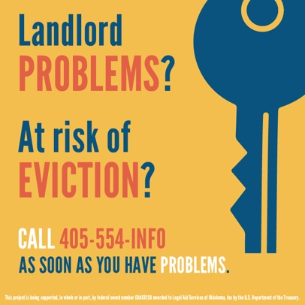  OKC Square 6 (English).png in Square Ratio | Problems with your landlord? @legalaidok might be able to help you. Call 405-554-INFO (4636) as soon as you begin having problems.
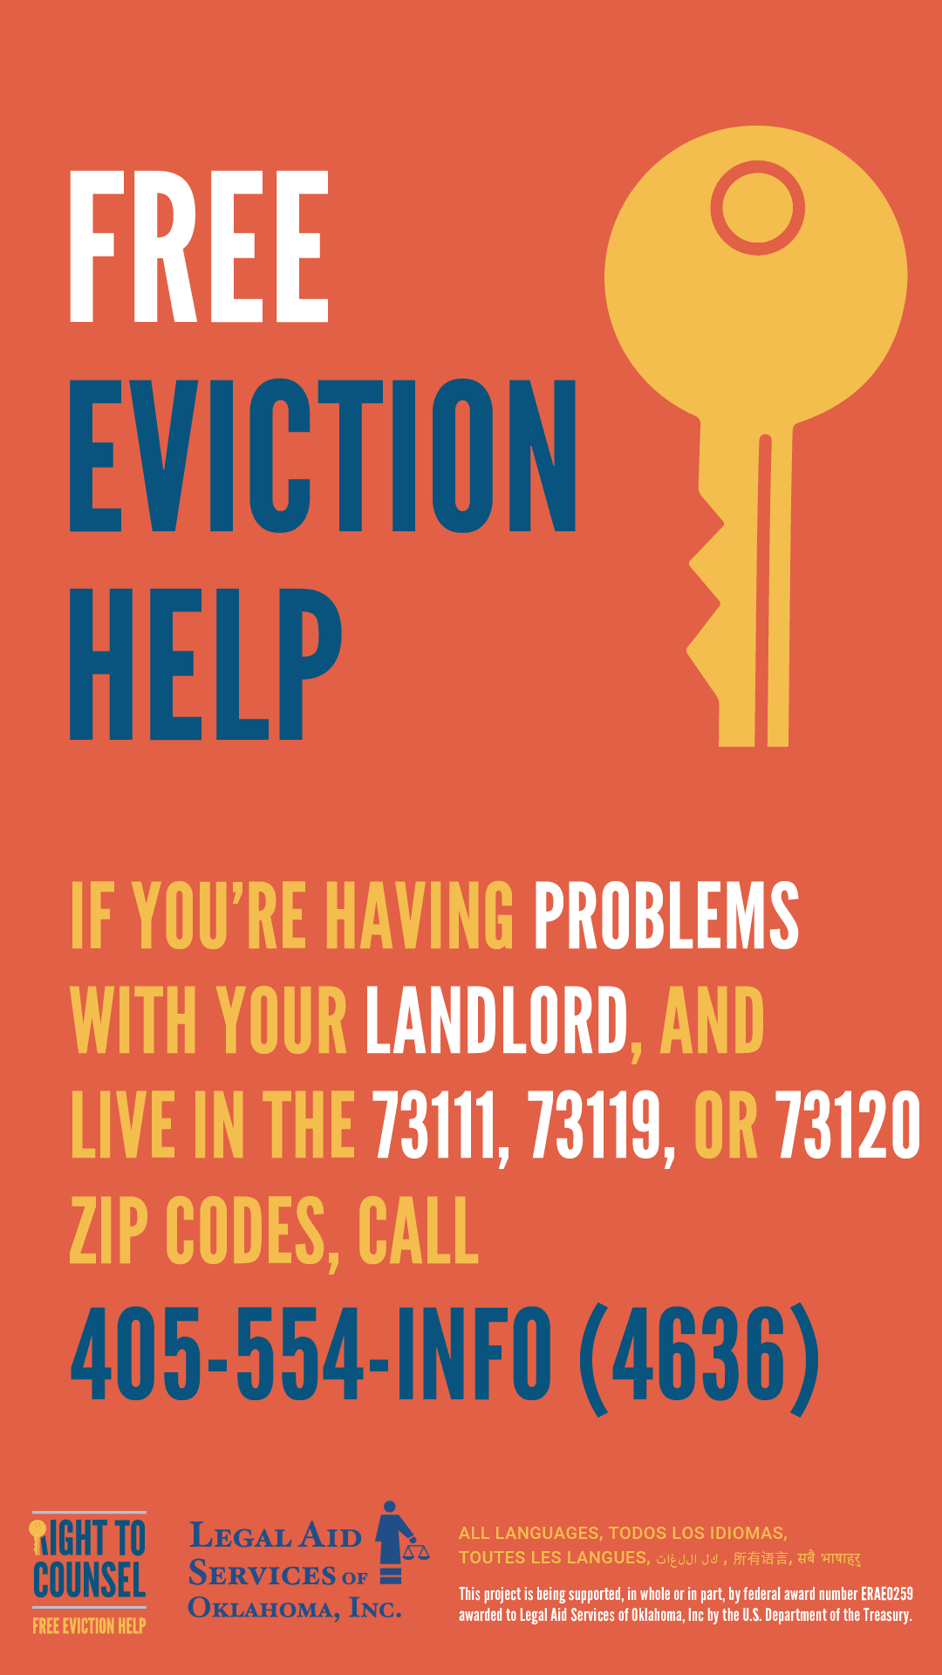  OKC Story 1 (English).png in Story Ratio | Stories on networks such as Facebook and Instagram don’t utilize captions. Instead, consider adding text to a slide in your stories after the graphic.
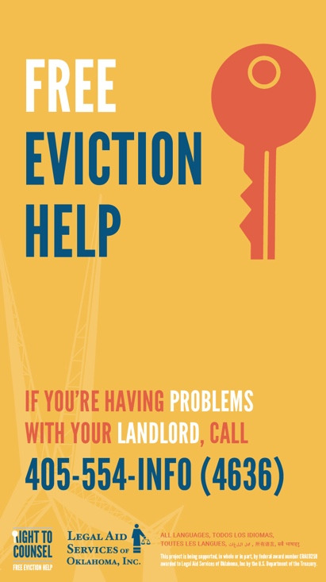  OKC Story 2 (English).png in Story Ratio | Stories on networks such as Facebook and Instagram don’t utilize captions. Instead, consider adding text to a slide in your stories after the graphic.
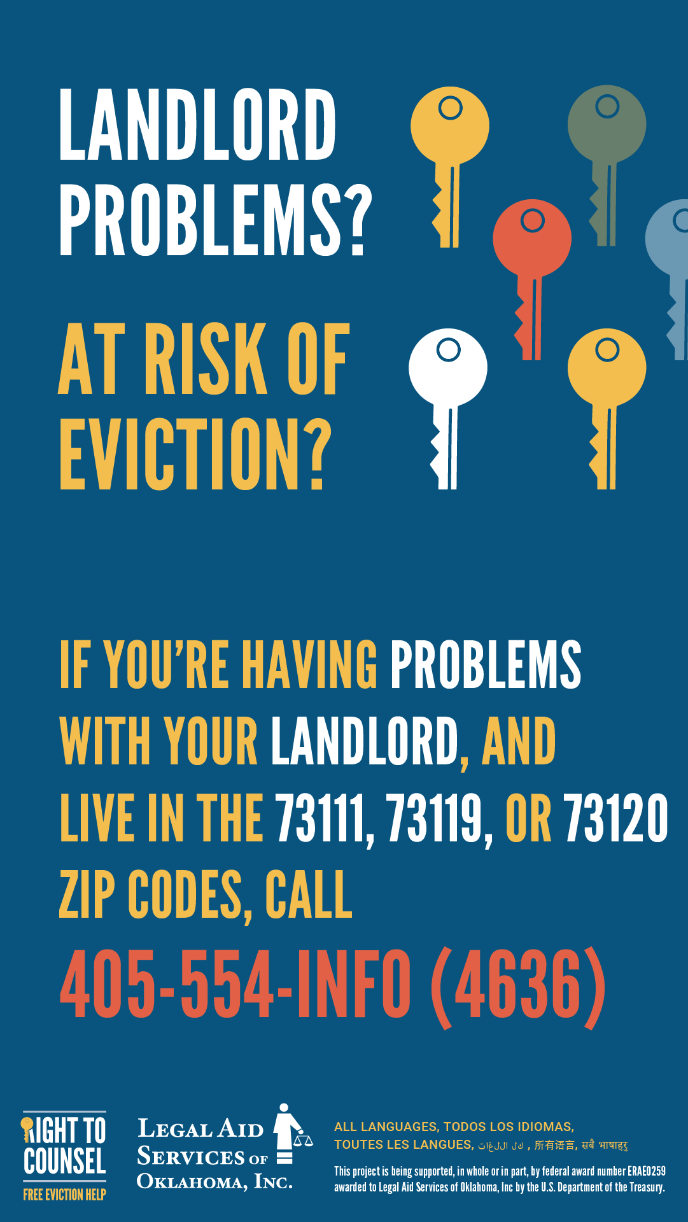  OKC Story 3 (English).png in Story Ratio | Stories on networks such as Facebook and Instagram don’t utilize captions. Instead, consider adding text to a slide in your stories after the graphic.
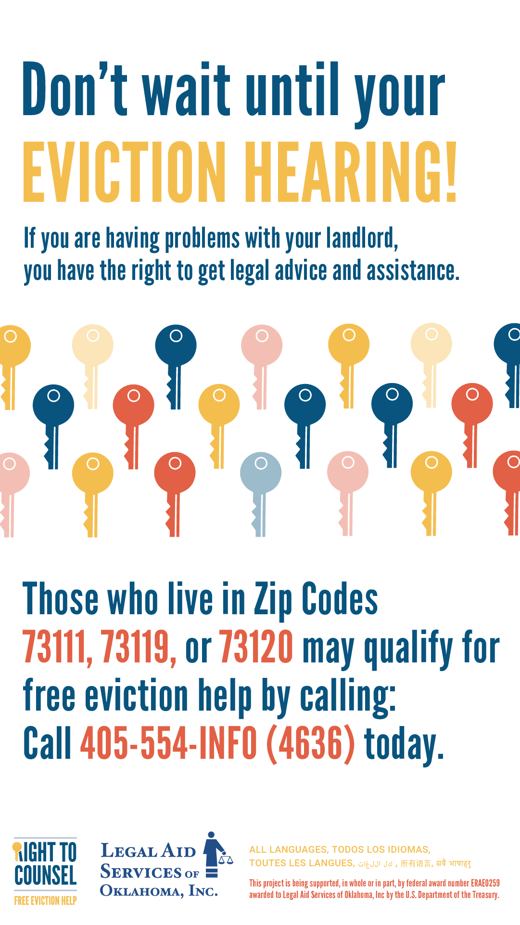  OKC Story 4 (English).png in Story Ratio | Stories on networks such as Facebook and Instagram don’t utilize captions. Instead, consider adding text to a slide in your stories after the graphic.
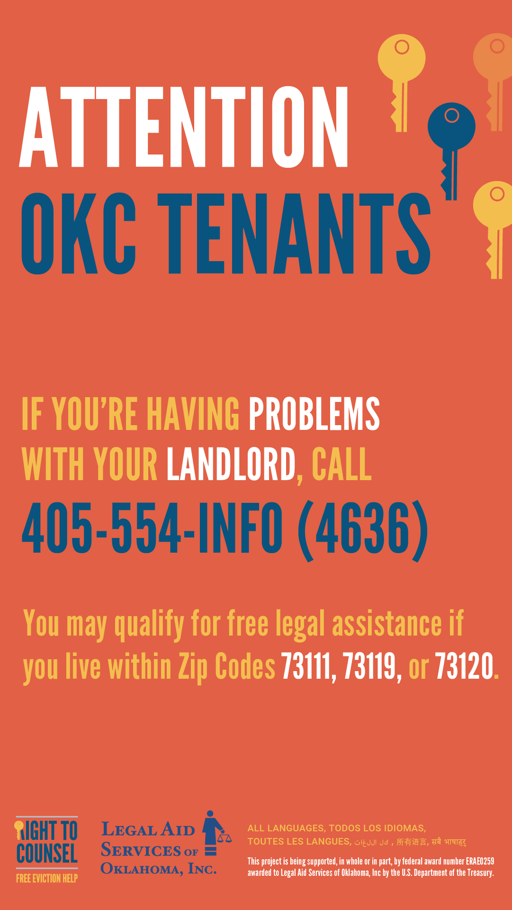  OKC Story 5 (English).png in Story Ratio | Stories on networks such as Facebook and Instagram don’t utilize captions. Instead, consider adding text to a slide in your stories after the graphic.
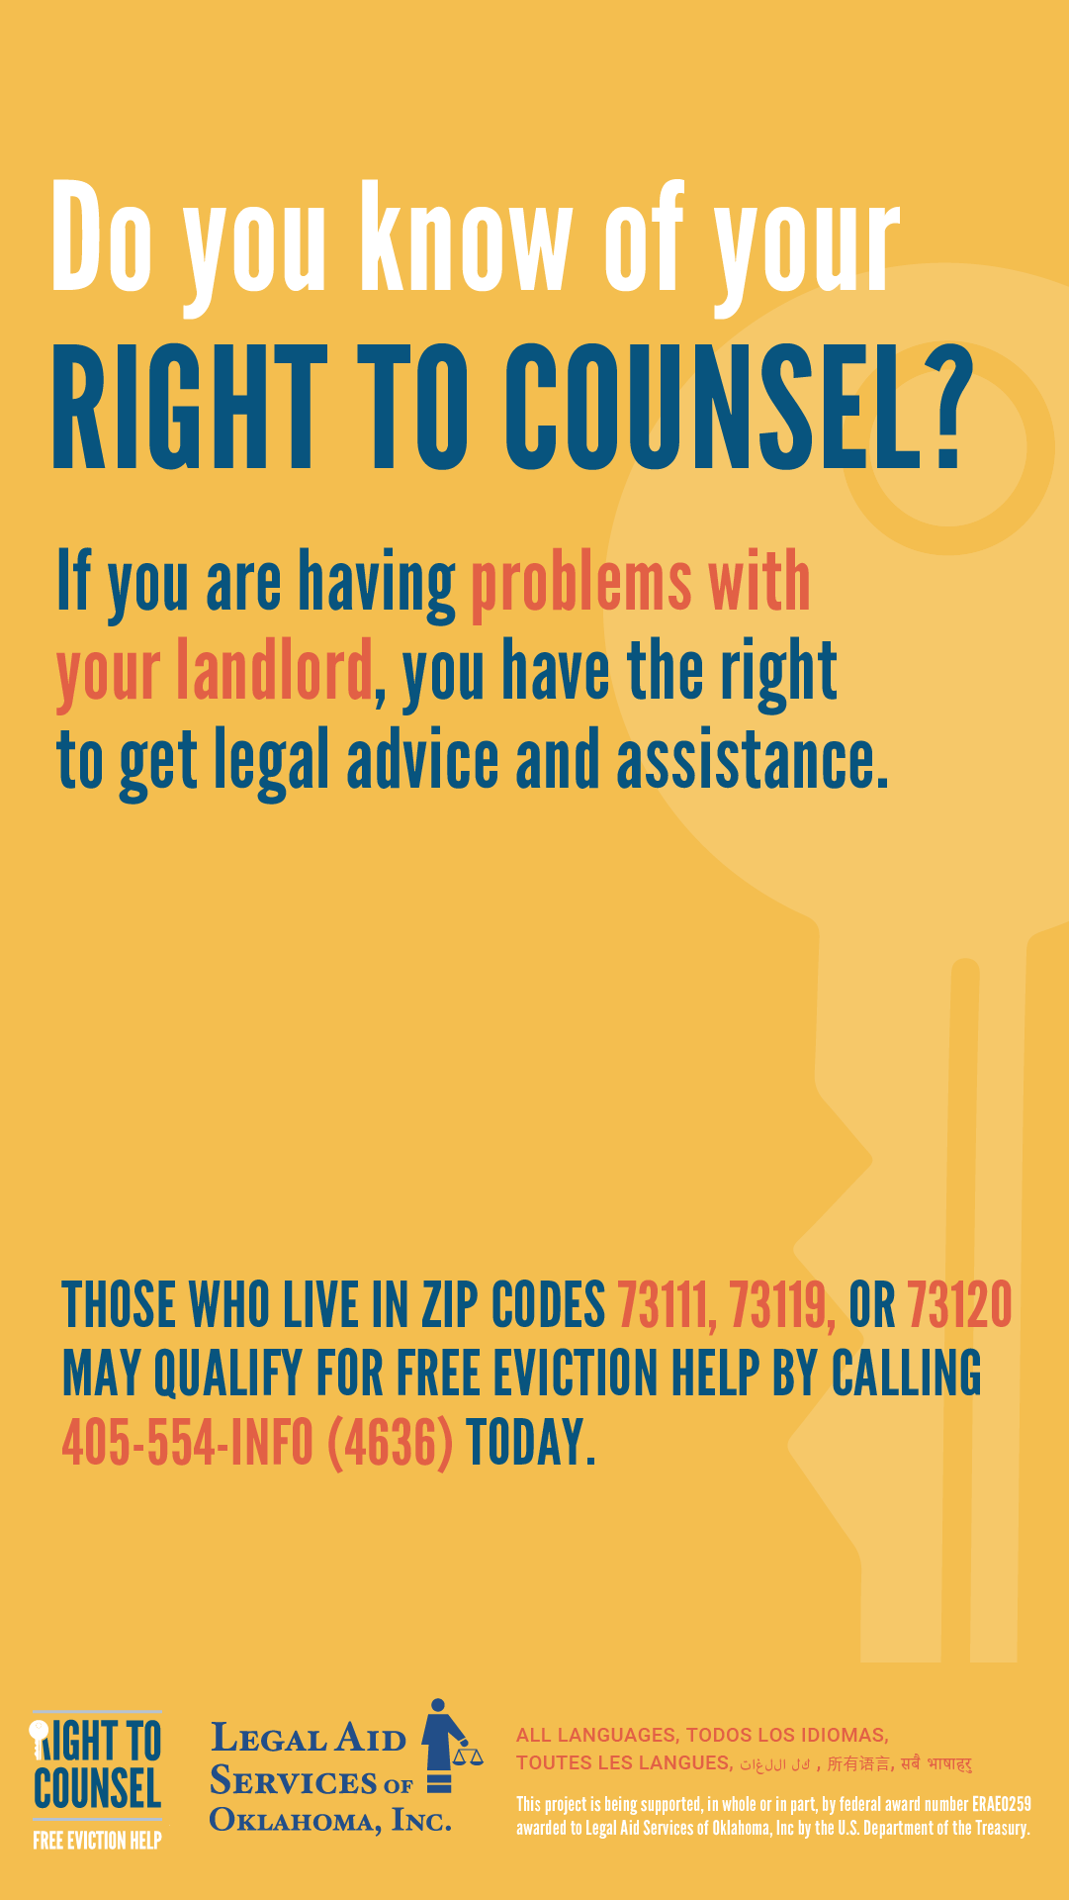  OKC Story 6 (English).png in Story Ratio | Stories on networks such as Facebook and Instagram don’t utilize captions. Instead, consider adding text to a slide in your stories after the graphic.
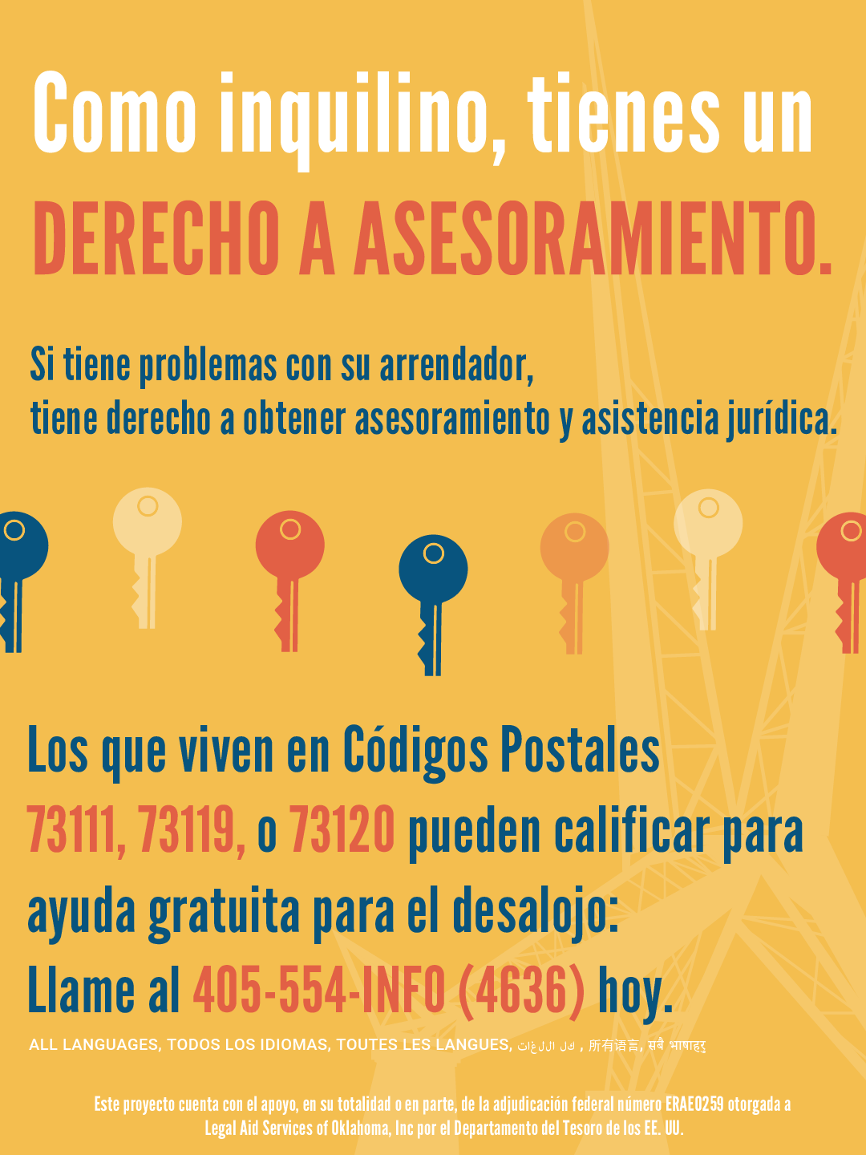  OKC Port 6 (Spanish).png in Portrait Ratio | Si se enfrenta a un desalojo o tiene problemas con el propietario, tiene derecho a obtener asesoramiento o representación legal para ayudarlo. Puede calificar para recibir ayuda gratuita de @legalaidok si vive en los códigos postales 73111, 73119, o 73120.  Llame al 405-554-4636 tan pronto como comience a tener problemas.  ¿No vives en estos códigos postales? Todavía hay ayuda e información disponible para sus problemas de propietario o desalojo. Visite https://oklaw.org/issues/housing/evictions
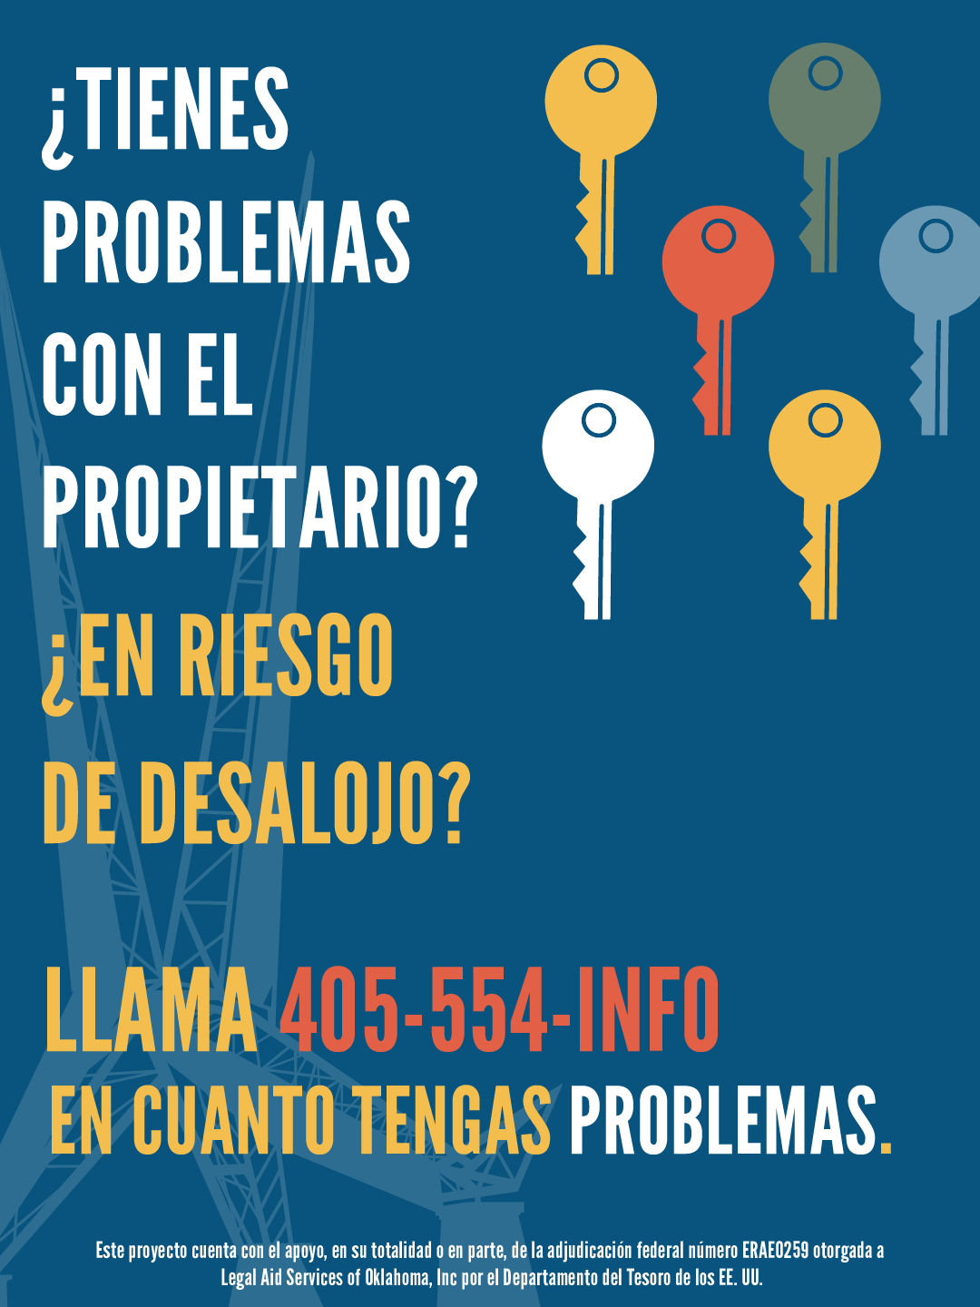  OKC Port 3 (Spanish).png in Portrait Ratio | Si se enfrenta a un desalojo o tiene problemas con el propietario, tiene derecho a obtener asesoramiento o representación legal para ayudarlo. Puede calificar para recibir ayuda gratuita de @legalaidok si vive en los códigos postales 73111, 73119, o 73120.  ¿No vives en estos códigos postales? Todavía hay ayuda e información disponible para sus problemas de propietario o desalojo. Visite https://oklaw.org/issues/housing/evictions
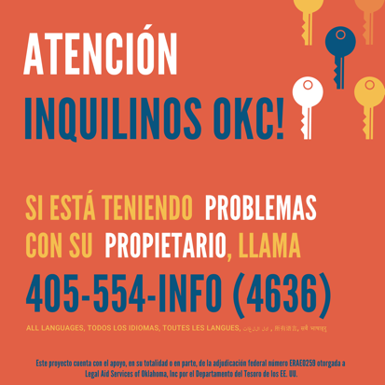  OKC Square 5 (Spanish).png in Square Ratio | ¡Ayuda para los inquilinos de OKC que tienen problemas con su arrendador! Llame a @legalaidok tan pronto como comience a tener problemas: 405-554-4636 si vive en los códigos postales 73111, 73119, o 73120.  ¿No vives en estos códigos postales? Todavía hay ayuda e información disponible para sus problemas de propietario o desalojo. Visite https://oklaw.org/issues/housing/evictions
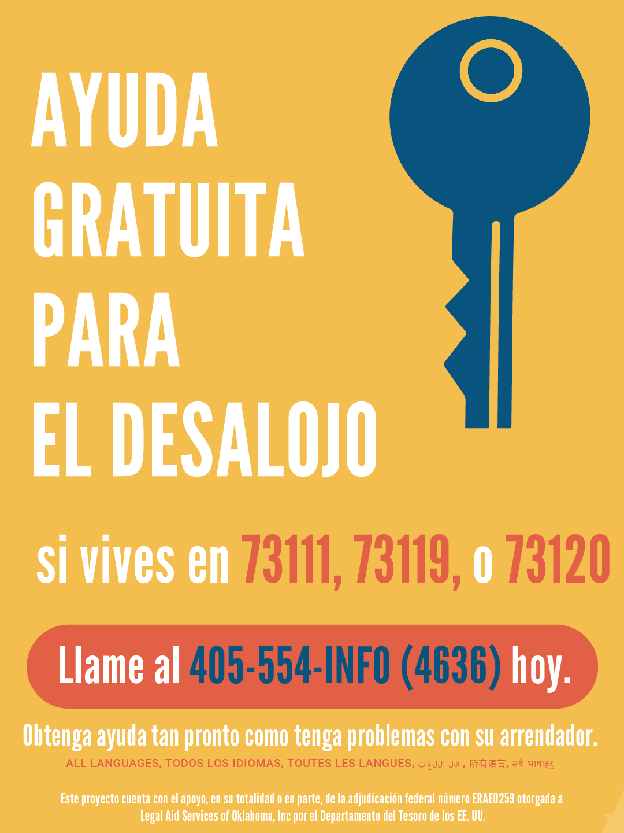  OKC Port 2 (Spanish).png in Portrait Ratio | Creemos que debe saber sobre la ayuda gratuita de desalojo de @legalaidok para quienes viven en los códigos postales 73111, 73119, o 73120. Llame al 405-554-INFO (4636) tan pronto como tenga problemas con el propietario.  ¿No vives en estos códigos postales? Todavía hay ayuda e información disponible para sus problemas de propietario o desalojo. Visite https://oklaw.org/issues/housing/evictions
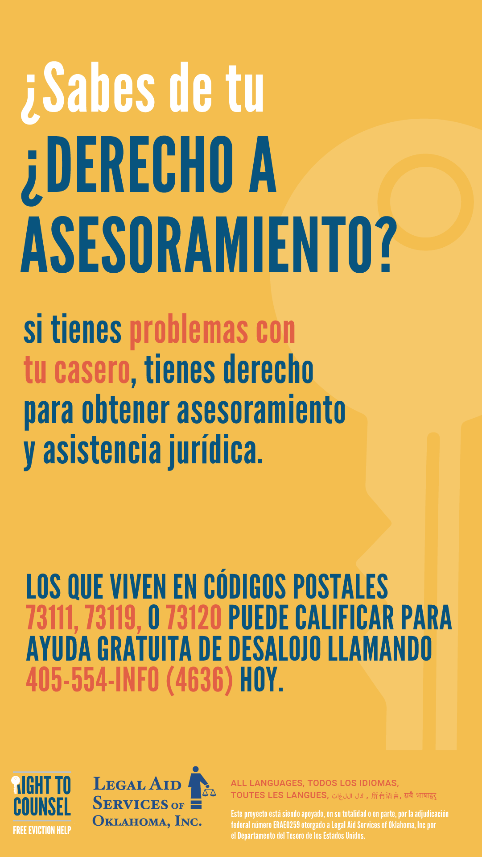  OKC Story 6 (Spanish).png in Story Ratio | Las historias en redes como Facebook e Instagram no utilizan subtítulos. En su lugar, considere agregar texto a una diapositiva en sus historias después del gráfico.

